**Scope Management Plan**

**APWA Self-Assessment**

**April 2, 2015**

# Introduction

The Scope Management Plan provides the scope framework for the APWA Self-Assessment. This plan documents the scope management approach; roles and responsibilities as they pertain to project scope; scope definition; verification and control measures; scope change control; and the project’s work breakdown structure. Any project communication which pertains to the project’s scope should adhere to the Scope Management Plan.

The Public Works Department is seeking accreditation by the American Public Works Association (APWA). Public Works accreditation is the recognition that the agency subscribes to the concept of continuous improvement and has conducted an in-depth self-assessment of the agency's policies, practices and procedures. It is the verification and recognition of an agency for conformance with a recognized body of management practices, the Public Works Management Practices Manual. The manual contains 593 recommended practices that describe the critical elements necessary for a full-service public works agency to accomplish its mission. The accreditation process offers a systematic approach to examining every function in the organization.

Before applying for accreditation, the agency must conduct a documented self-assessment to determine the extent to which the agency meets applicable practices and assemble the necessary documentation of compliance with the recommended practices in the Public Works Management Practices Manual. Completion of the self-assessment serves as an important step towards accreditation.

# Scope Management Approach

For this project, scope management will be the sole responsibility of theproject manager. The scope for this project is defined by the Scope Statement, Work Breakdown Structure (WBS) and WBS Dictionary. The project manager, along withfive team members, will establish and approve documentation for measuring project scope which includes quality checklists, scope baseline and work performance practices.

Inputs to the Scope Management Plan includeaProject Management Plan**,** Project Charter**,** Enterprise Environmental Factors and Organizational Process Assets. The tools and techniques utilized are described herein, and the outputs include a Scope Management Plan, Requirements Management Plan, Requirements Documentation, Requirements Traceability Matrix, Scope Statement, Scope Baseline, WBS, WBS Dictionary, Change Requests, Project Document Updates, Project Management Plan Updates and Organizational Process Assets Updates.

Proposed scope changes may be initiated by theproject sponsor, manager and team members. All change requests will be submitted to the project manager who will then evaluate the requested scope change. Upon acceptance of the scope change request, the project manager will submit the scope change request to the project sponsor for acceptance. Upon approval of scope changes by the project sponsor, the project manager will update all project documents and communicate the scope change to all stakeholders. Based on feedback and input from the project manager and stakeholders, the project sponsor is responsible for the acceptance of the final project deliverables and project scope.

# Roles and Responsibilities

The project sponsor, manager and team memberswill all play key roles in managing the scope of this project. As such, the project sponsor, manager, and team members must be aware of their responsibilities in order to ensure that work performed on the project is within the established scope throughout the entire duration of the project. The table below defines the roles and responsibilities for the scope management of this project.

|  |  |  |
| --- | --- | --- |
| **Name** | **Role** | **Responsibilities** |
| Pat Thomas | Sponsor | * Approve or deny scope change requests as appropriate * Evaluate need for scope change requests * Accept project deliverables |
| Craddock Stropes | Project Manager | * Measure and verify project scope * Facilitate scope change requests * Facilitate impact assessments of scope change requests * Facilitate team level change review process * Organize and facilitate scheduled change control meetings * Communicate outcomes of scope change requests * Update project documents upon approval of all scope changes |
| Bonnie Elliott  Christie Marcella  Greg MacLellan  Jennifer Marinov  Consultant | Team Members | * Participate in defining change resolutions * Evaluate the need for scope changes and communicate them to the project manager as necessary * Validate scope change requests |
|  |  |  |
|  |  |  |

**Table 1.1, *Scope Management Roles and Responsibilities***

# Scope Definition

The scope for this project was defined through a comprehensive requirements collection process. The development of requirements started with a thorough analysis of the information contained in the Project Charter, the Stakeholder Register and the Stakeholder Management Plan. The project sponsor, manager and team members attended facilitated workshops to review the Public Works Management Practices Manual. The project manager also attended an APWA Self-Assessment Workshop to help develop a customized method for using the Public Works Management Practices Manual. From this information, the project team developed the Project Requirements Documentation, Requirements Management Plan, and the Requirements Traceability Matrix.

The project description and deliverables were developed based on the requirements collection process and input from subject matter experts. Personnel from other public works agencies within the local APWA Chapter met with the department to review and discuss compliance with management practices. APWA also provided individuals that are well-versed and experienced in the field of public works to conduct an onsite visit to review operations of the agency. Interviews were conducted with staff from parks & recreation which is a department also seeking accreditation. This process of expert judgment provided feedback on the most effective ways to conducting the self-assessment.

# Project Scope Statement

The Project Scope Statement provides a detailed description of the project, deliverables, constraints, exclusions, assumptions, and acceptance criteria. Additionally, the Scope Statement includes what work should not be performed in order to eliminate any implied but unnecessary work which falls outside the project’s scope.

The Public Works Department will conduct a self-assessment which includes a review, evaluation and comparison of all internal policies, procedures and practices against the Public Works Management Practices Manual. Deliverables for this project include procurement of a gap analysis consultant that will assist with the submittal of the self-assessment to the APWA. The consultant will review and compare all existing policies, procedures and practices to APWA practices and prepare a gap analysis report and presentation including recommendations for correcting deficiencies. The project manager will complete and submit an APWA Self-Assessment Application. The project manager will then attend an APWA Self-Assessment Training Workshop to help develop a customized method for using the Public Works Management Practices Manual. The project will be accepted once all public works practices are documented with backup materials and uploaded into the APWA self-assessment software. An onsite visit by peers will be conducted in order to review agency operations and give suggestions on completeness of policies, procedures and practices. An APWA Self-Assessment Peer Review and Report will be completed following the onsite visit. Although the self-assessment is the first phase towards accreditation, this project does not include APWA Accreditation.

The department will face many constraints with completing the self-assessment. Institutional knowledge may be hard to obtain due to a number of new employees in the department. Current workloads will make it challenging for employees to fully contribute and focus on the project. Not all staff within city may be willing to contribute within time frame of project due to other demands. Since the project is very specific, there may be a limited number of qualified consultants for the recruitment pool. During gap analysis, some practices may not exist, be documented correctly or thoroughly. The department’s language of practices or measuring may not match APWA language. Policies, procedures, and practices may need to be approved by too many people with conflicting philosophies. Peers from outside agencies may not be available for review of management practices within timeframe of project.

To complete the self-assessment, the project team and stakeholders assume that all Public Works employees will contribute to the project. Departments outside Public Works will assist with policies, procedures and practices within their realm of responsibility. An outside qualified consultant will be obtained. APWA self-assessment software will be utilized for documentation and tracking and MS Project will be able to be utilized for project management. Many Public Works policies, procedures and practices have already beendocumented and are classified as best practices so slight editing and/or little modification will need to be done. Peers from outside agencies will be willing to serve as mentors and/or review and discuss compliance with management practices. Overtime may be utilized to ensure project is on schedule.

# Work Breakdown Structure

In order to effectively manage the work required to complete this project, it will be subdivided into individual work packages. This will allow the project manager to more effectively manage the project’s scope as the project team works on the tasks necessary for project completion. The project is broken down into six phases: initiate, plan, project kick-off, self-assessment execution, monitor self-assessment and close out self-assessment. Each of these phases is then subdivided further down to work packages which are outlined in the WBS.

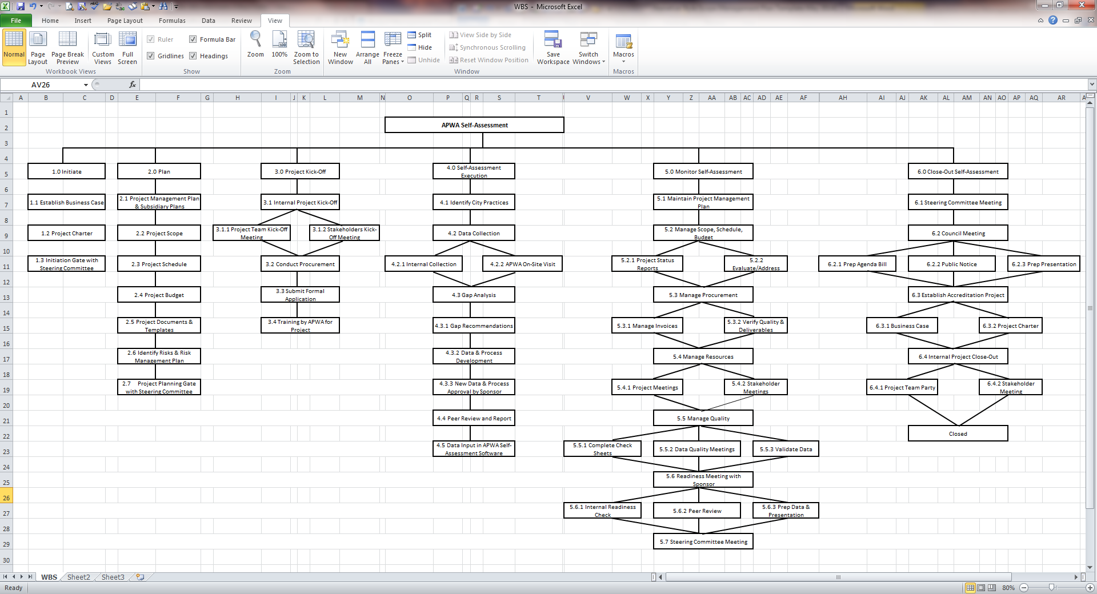

**Figure 1.1, *Work Breakdown Structure (WBS)***

In order to more clearly define the work necessary for project completion the WBS Dictionary is used. The WBS Dictionary includes an entry for each WBS element. The WBS Dictionary includes a detailed description of work for each element and the deliverables, budget and resource needs for that element. The project team will use the WBS Dictionary as a statement of work for each WBS element.

|  |  |  |  |  |  |  |
| --- | --- | --- | --- | --- | --- | --- |
| Level | WBS Code | Element Name | Description of Work | Deliverables | Budget | Resources |
| 2 | 1.0 | Initiate | Present business case to sponsor for approval    Develop charter    Create project team  Identify steering committee  Project initiation gate presentation for steering committee | Business Case  Project Charter  Project Team  Steering Committee |  | Project Sponsor  Project Manager  Project Team  Steering Committee |
| 2 | 2.0 | Plan | Develop management plan  Identify and document scope, schedule, budget, quality, requirements, stakeholders, risks, methods of communication  Develop group decision-making techniques, WBS, checklist templates  Identify resources  Project planning gate meeting with steering committee | Project Management Plan  Project plans for scope, schedule, budget, quality, risk, stakeholders, communication,& procurement  Documents & templates developed |  | Project Sponsor  Project Manager  Project Team  Steering Committee |
| 2 | 3.0 | Project Kick-off | Develop RFQ  Recruit and secure consultant    Conduct kick-off meetings  Complete and submit APWA self-assessment application  Schedule and conduct trainings | Procurement of consultant  Formal application submitted  Kick-off meetings  Training | $30K | Project Sponsor  Project Manager  Project Team  Steering Committee  Contract Administration  Consultant  Public Works |
| 2 | 4.0 | Self-Assessment Execution | Collect, review, revise and compare policies, procedures and practices against checklist  Conduct gap analysis  Develop, approve and implement policies, procedures and practices  Conduct outside peer review  Input data into APWA self-assessment software. | Practices identified  Data collected & in APWA software  Gap analysis  Policies, procedures and documentation approved  Outside peer review and report |  | Project Sponsor  Project Manager  Project Team  Steering Committee  Consultant  Public Works  Finance  Risk  Human Resources  Communications IT  Police  CED  Parks & Recreation    APWA self-assessment software  MS Project |
| 2 | 5.0 | Monitor Self-Assessment | Manage procurement, scope, schedule, budget, quality, resources  Readiness gate meeting with steering committee | Updated project management plan  Updated project plans for scope, schedule, budget, quality, risks, stakeholders, communication & procurement |  | Project Sponsor  Project Manager  Project Team  Steering Committee  Consultant |
| 2 | 6.0 | Close Out Self- Assessment | Prepare Agenda Bill for Council approval  Approve all policies, procedures and practices by sponsor  Conduct stakeholder closing meeting  Closing gate meeting with steering committee  CELEBRATE!  Determine business case for accreditation process | Agenda Bill  Self-assessment approval  Internal project closure  Party  Business case for accreditation |  | Project Sponsor  Project Manager  Project Team  Steering Committee  Consultant  City Council |

**Table 1.2, *WBS Dictionary***

**Scope Verification**

As this project progresses the project manager will verify interim project deliverables against the original scope as defined in the Scope Statement, WBS and WBS Dictionary. Once the project manager verifies that the scope meets the requirements defined in the project plan, the project manager and project sponsor will meet for formal acceptance of the deliverable. During this meeting the project manager will present the deliverable to the project sponsor for formal acceptance. The project sponsor will accept the deliverable by signing a project deliverable acceptance document. This will ensure that project work remains within the scope of the project on a consistent basis throughout the life of the project.

# Scope Control

The project manager and the project team will work together to control the scope of the project. The project team will leverage the WBS Dictionary by using it as a statement of work for each WBS element. The project team will ensure that they perform only the work described in the WBS dictionary and generate the defined deliverables for each WBS element. The project manager will oversee the project team and the progression of the project to ensure that this scope control process if followed.

If a change to the project scope is needed the process for recommending changes to the scope of the project must be carried out. Any project team member can request changes to the project scope. All change requests must be submitted to the project manager in the form of a project change request document. The project manager will then review the suggested change to the scope of the project. The project manager will then either deny the change request if it does not apply to the intent of the project or convene a change control meeting between the project team to review the change request further and perform an impact assessment of the change. If the change request receives initial approval by the project manager, the project manager will then formally submit the change request to the project sponsor. If the project sponsor approves the scope change, the project sponsor will then formally accept the change by signing the project change control document. Upon acceptance of the scope change by the project sponsor, the project manager will update all project documents and communicate the scope change to all project team members and stakeholders.

# 

# Sponsor Acceptance

Approved by the Project Sponsor:

Date:

Pat Thomas

Public Works Director